Deliverable 5: TO-BE Integration Architecture
Company: Aegis Health Partners
The Integration Architecture defines exactly how data moves between the siloed enterprise systems. To achieve the "Zero-Touch Provisioning" goal, this architecture shifts Aegis from manual data entry to a fully automated, Event-Driven Integration model.
1. Integration Strategy: APIs vs. Events
The architecture utilizes three distinct communication patterns depending on the urgency and structure of the data:
- Event-Driven (Webhooks & Messaging): Used for state changes. When an employee's status changes in HR, a webhook is fired immediately. Apache Kafka queues these events to ensure guaranteed delivery even if downstream systems are busy.
- Synchronous APIs (RESTful JSON): Used for transactional actions where immediate confirmation is required, such as requesting a FedEx shipping label or creating a Coupa Purchase Order.
- Continuous Data Streaming: Used for high-velocity IoT telemetry. MDM clients stream battery and CPU data directly into the time-series database (InfluxDB) without bogging down the API gateway.
2. Integration Flow Diagram
This diagram illustrates the real-time event flow of a doctor offboarding process, demonstrating how the integration layer orchestrates APIs across four different platforms without human intervention.
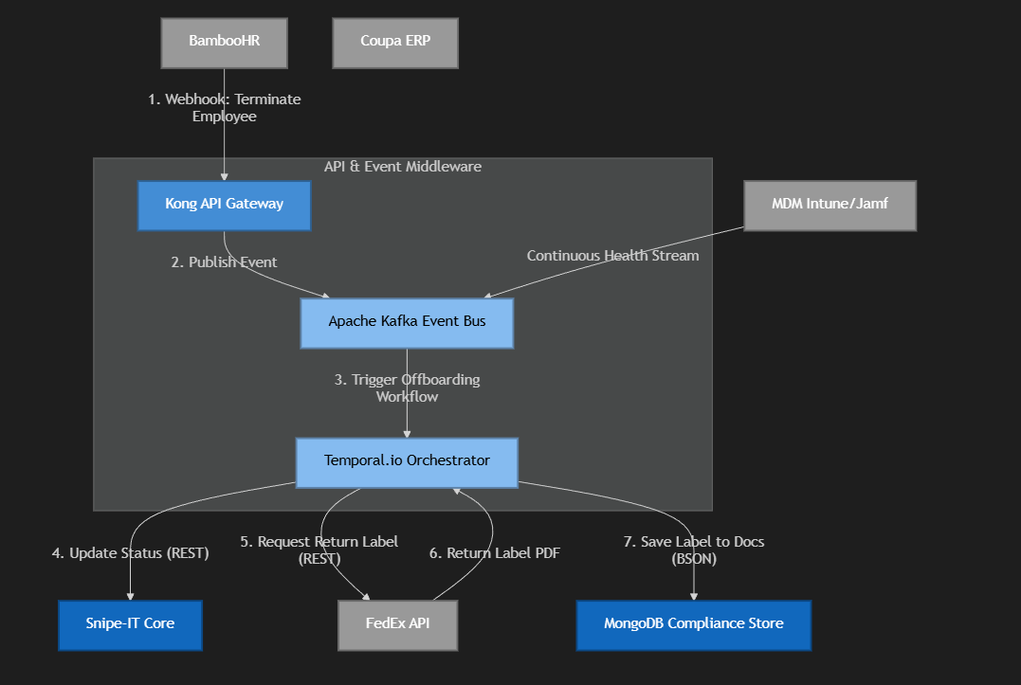
3. Key System Integrations
A. Human Resources: BambooHR Integration
- Method: Outbound Webhooks (from BambooHR) to Kong API Gateway.
- Payload: JSON containing employee_id, status (Hired, Terminated, On Leave), and shipping_address.
- Purpose: Acts as the primary trigger for all ITAM workflows. It ensures IT provisions equipment the second a contract is signed and revokes access the second an employee resigns.
B. Procurement & Finance: Coupa ERP Integration
- Method: Synchronous REST API calls (from Middleware to Coupa).
- Payload: Purchase Requisition JSON containing model_id, vendor, and cost_center.
- Purpose: When Snipe-IT detects inventory is too low to satisfy an incoming BambooHR onboarding request, the middleware automatically triggers an API call to Coupa to order a new telehealth kit, eliminating manual IT purchasing emails.
C. Logistics: FedEx / Courier Integration
- Method: Synchronous REST API calls.
- Payload: Origin address, destination address, and package weight.
- Purpose: Automatically generates secure, tracked return shipping labels for offboarded doctors. The PDF label is parsed and automatically emailed to the doctor's personal email address to recover the $3,000 diagnostic kit.
D. Device Management: Jamf / Intune Integration
- Method: Polling APIs & Direct Streaming.
- Payload: Hardware telemetry (Battery Cycle Count, OS Version, Disk Health, Last Known IP).
- Purpose: Syncs real-world physical device data with the Snipe-IT database. If Snipe-IT thinks a device is in the Manila Clinic, but the MDM IP address shows it in Cebu, the integration flags an audit anomaly.

